The Oms-Or Mansion

**Worldwide Haunted Board Game!**

Game Theme Overview

Ever want to play a horror board game but don’t have enough players to play? We present you the ultimate online horror video game for the current generation of video game consoles. It has everything you love about a horror board game but instead of a board game, it comes alive in a virtual world. And best of all, you can play online with friends or with people you meet within the game.

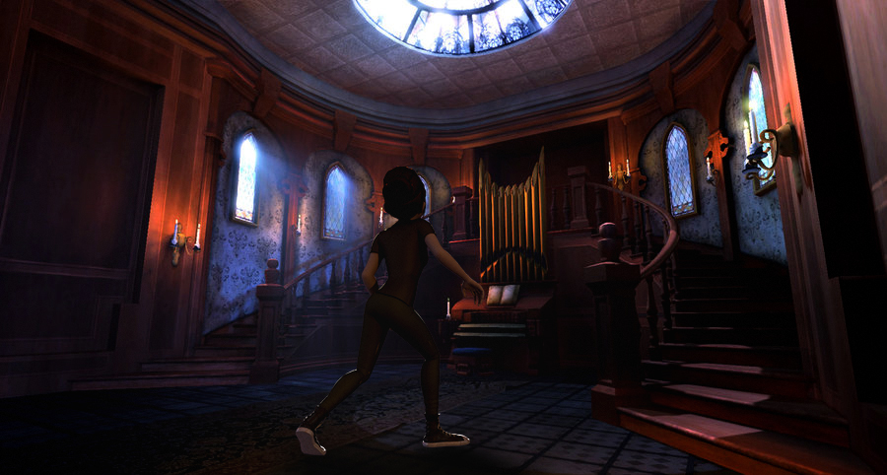

Executive Summary

Platforms: XBOX One, PS4, Wii-U, PC

Price: Free-to-Play Model

Rating: T

Target Audience: Teens and Adults

Genre: MMO-Action-adventure Survival Horror

Major Features:

1. It’s not just a single player survival horror game but a **group of adventures** trying to survival a night at The Oms-Or Mansion.
   1. The base game is **free** to download and play! The game includes an in-game shop that offers **cosmetic items** for your adventures.
2. You can buy or earn new adventures that will **unlock new challenges** that you and your friends can then face during the game. Just like if you buy new expansion to a board game, only one person has to buy it among friends.

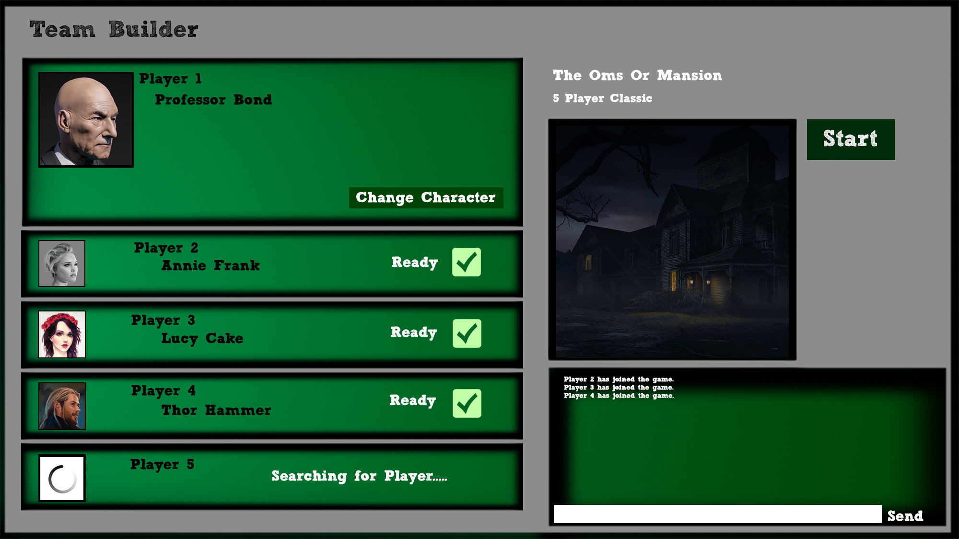

**You can play at any time!** You don’t have to wait for friends to play. You have the option to be teamed up **with friends and/or random players** around the world.

**Huge replay value!** Every time you play, the game independently randomizes the house, events, items, and horrors based on adventures present and level of the adventurers.